Objective Questions

- Are there any tables with duplicate or missing null values? If so, how would you handle them?
Ans: There are NO tables with duplicates or null values.
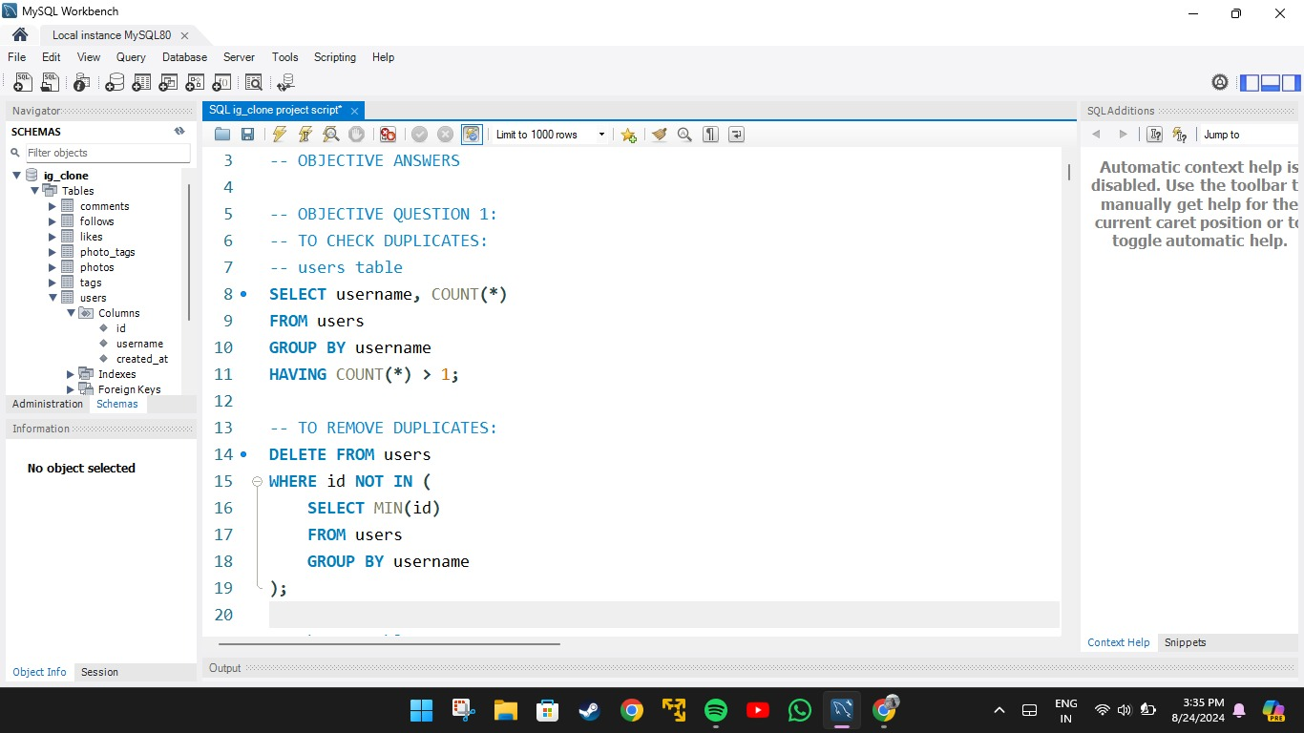
- The above query Retrieves the username and counts number of times username appears, groups the records by username so that its unique and filters the groups to only include those that appear more than once.
- To delete the duplicates it selects the smallest id for each username group keeping only one instance of each username in table.
………………………………………………………………………………………..
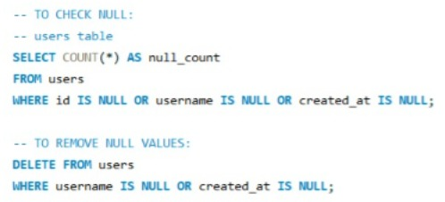
- Retrieves count of records with null values from each column as null_count.
- It deletes the records with null value from columns username and created_at of user table.
- This same queries can be modified to check for duplicates and null values in other tables.

- What is the distribution of user activity levels (e.g., number of posts, likes, comments) across the user base?
Ans: This query counts the number of posts, number of likes, number of comments by each user even if there are no posts, comments or likes. The “LEFT JOIN” is used connect likes, comments and photos table with users table.
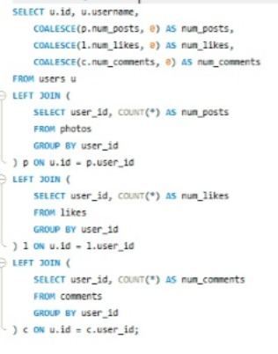
OUTPUT:
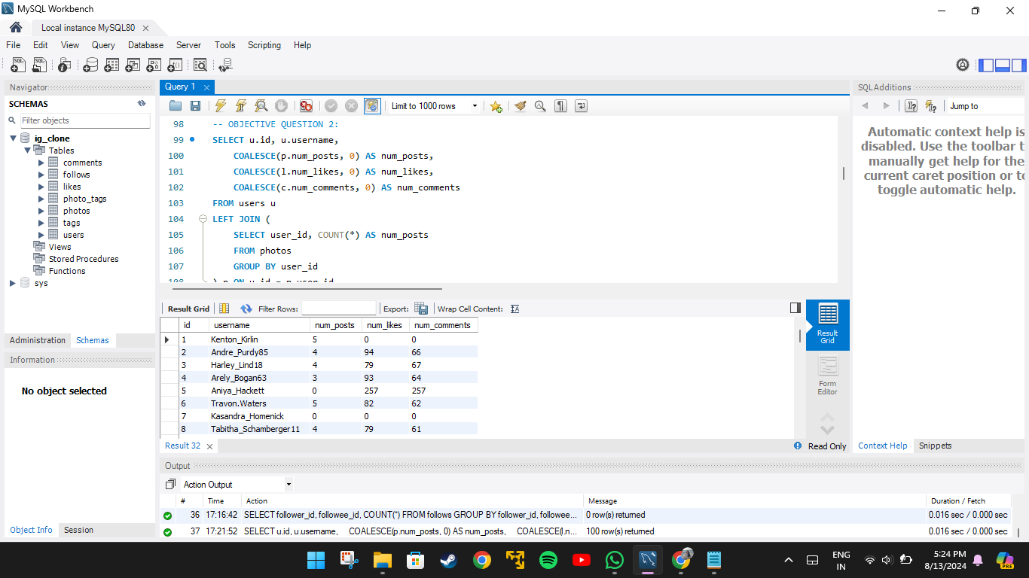

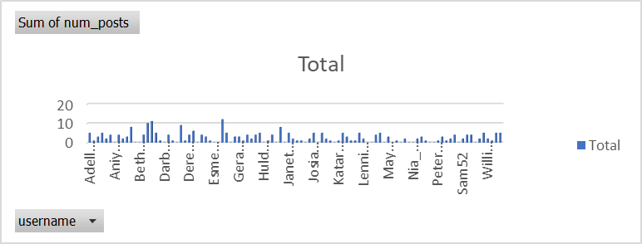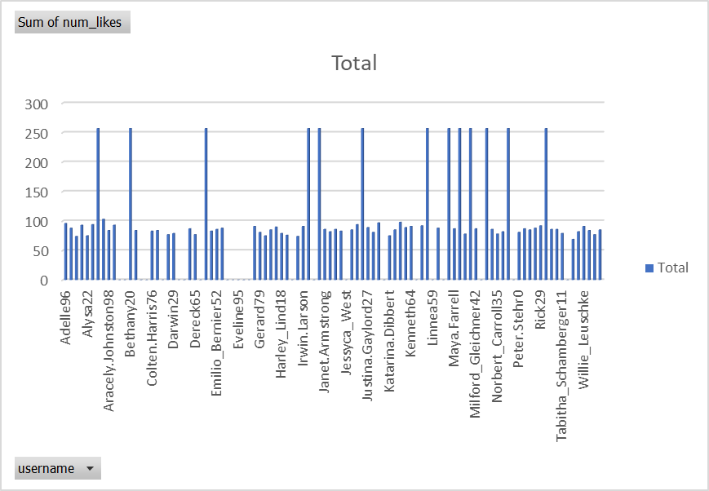
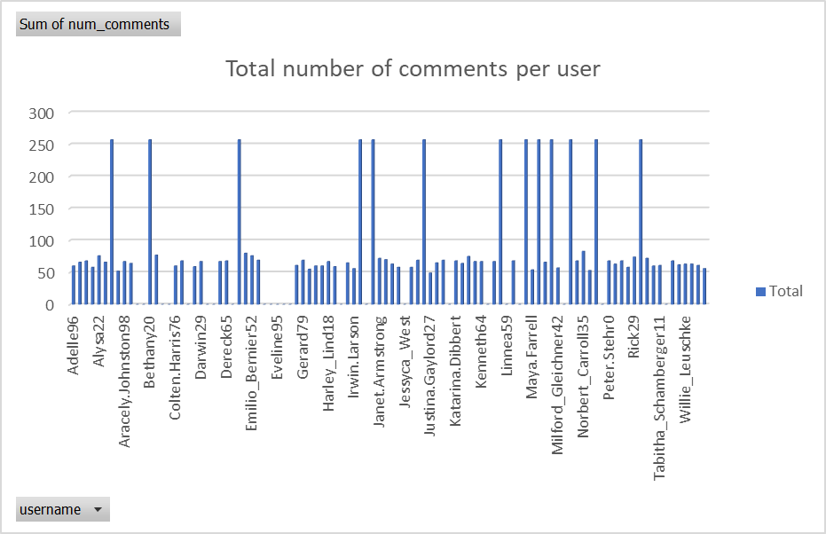

- Calculate the average number of tags per post (photo_tags and photos tables).
Ans: This query calculates the count of tags for each photo in the subquery and then calculates the average count of the tags as avg_tags_per_post.

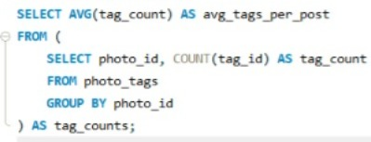
OUTPUT:
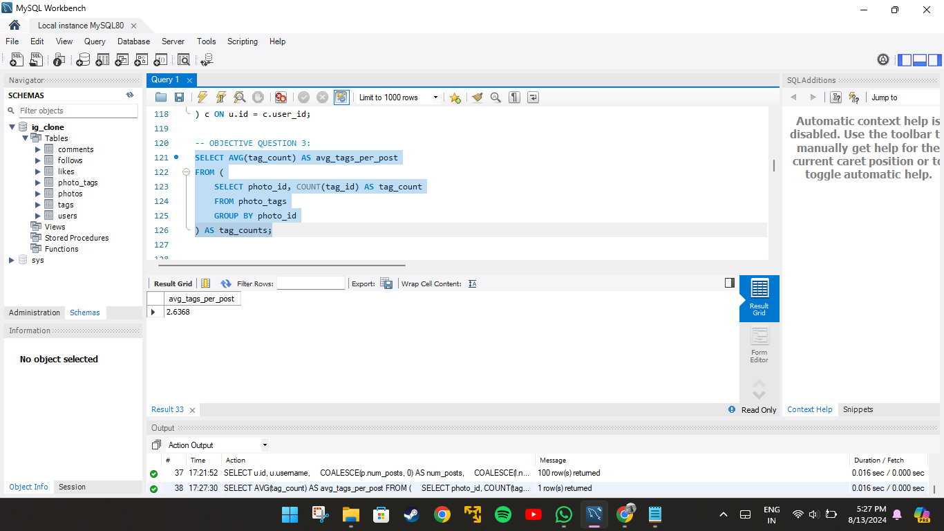
- From the output we can analyse that the average number of tags per post is 3 ..

.
- Identify the top users with the highest engagement rates (likes, comments) on their posts and rank them.
Ans: This query counts the number of likes and number of comments for each post and view is created for future use. The user engagement is calculated by adding the number of likes and comments and then dividing it by total number of posts. “DENSE_RANK” id used to rank users based on their engagement rate for those users who have posted atleast one photo and “LET JOIN” is used to connect users table with the other tables.

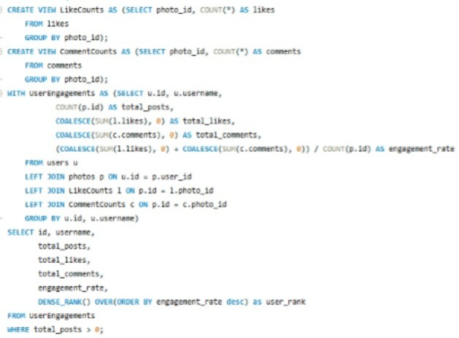
OUTPUT:
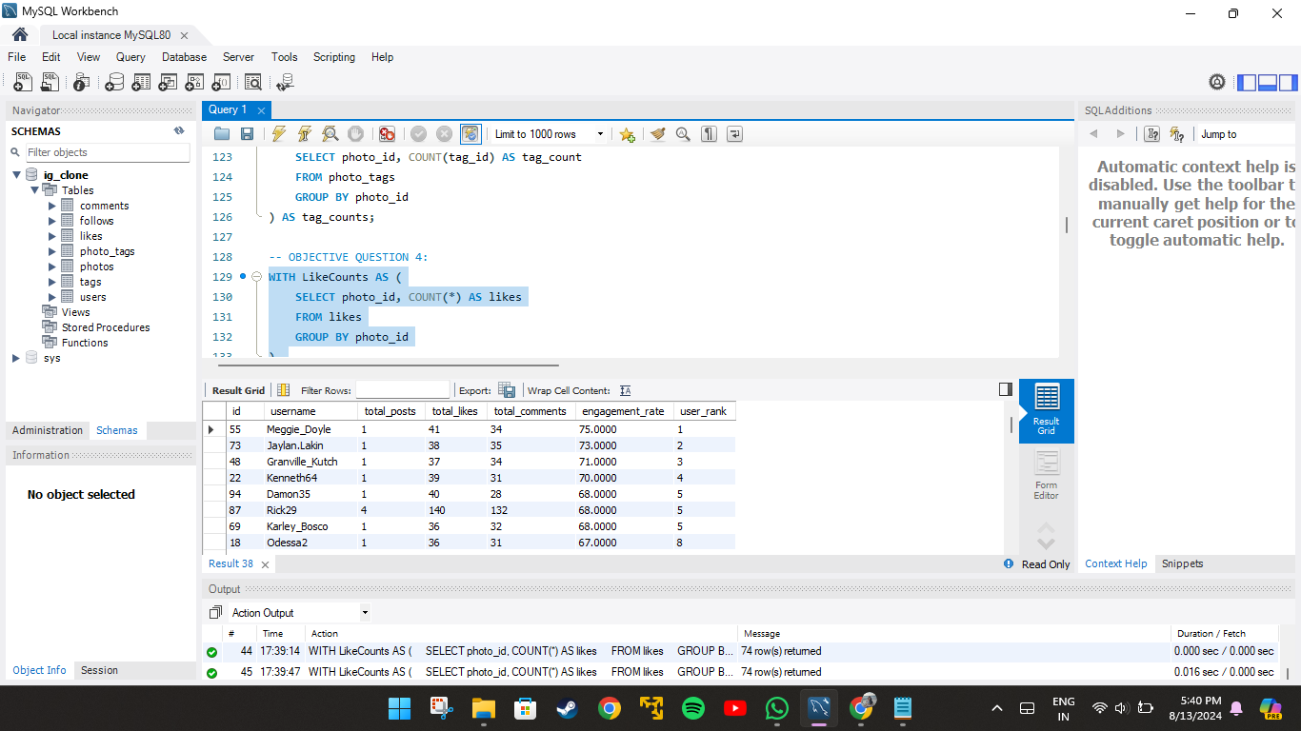
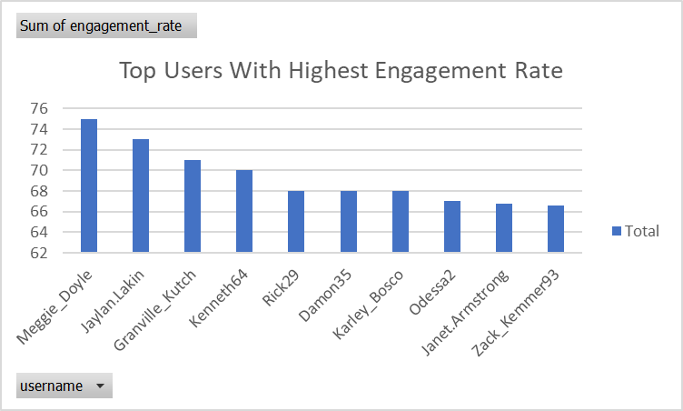

- Which users have the highest number of followers and followings?
Ans: This query returns the users id, username and followers or following count. “LIMIT” is used retrieve the first user in the order.
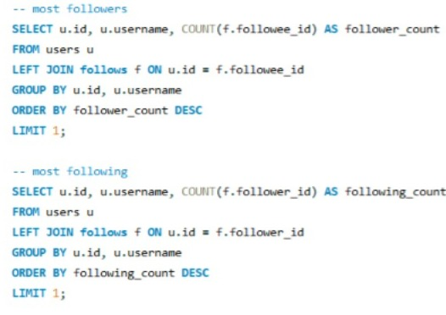
OUTPUT:
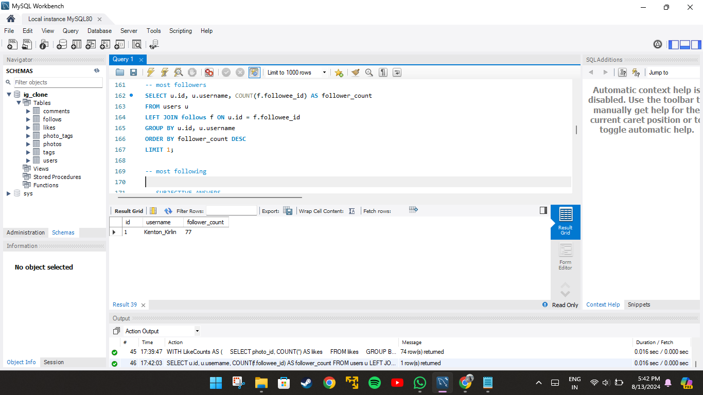
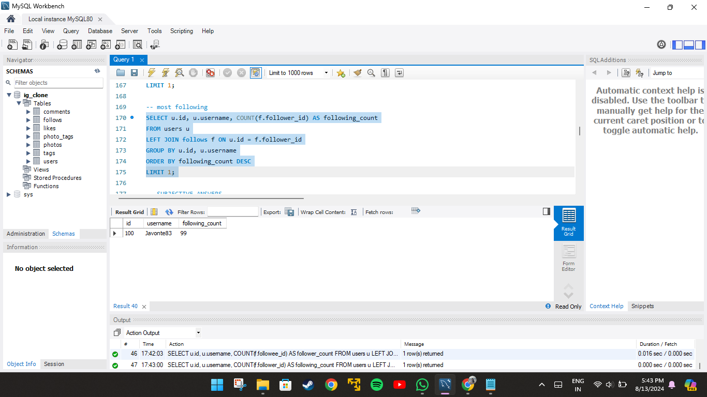

- Calculate the average engagement rate (likes, comments) per post for each user.
Ans: This query calculates the engagement rate same as in the objective question 4 i.e, (total likes + total comments) / total posts. The query returns users id, username and user engagement rate for users who have atleast one post.

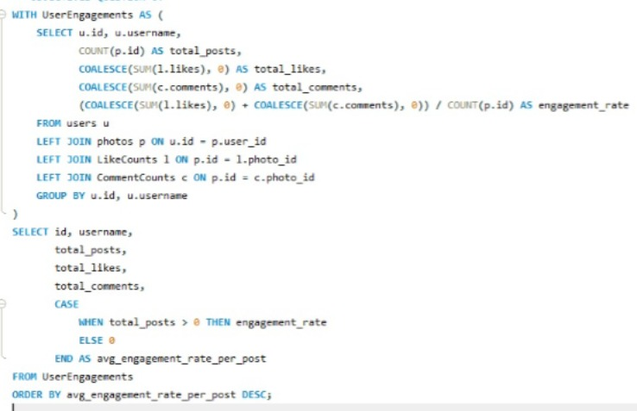
OUTPUT:
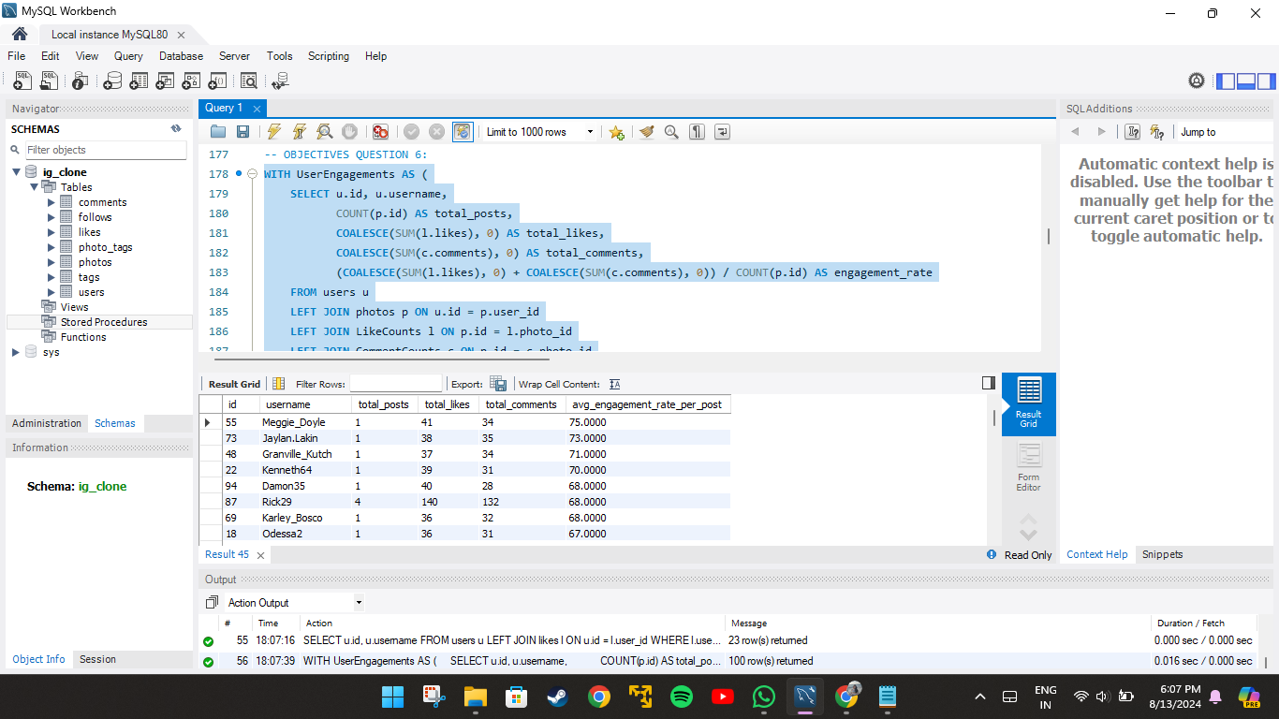
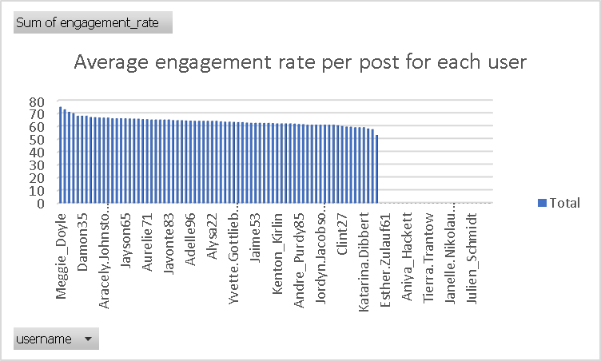

- Get the list of users who have never liked any post (users and likes tables)
Ans: This query retrieves the id and username of the users whose id is not found in the likes table. “LEFT JOIN” is used to connect users table with likes table.
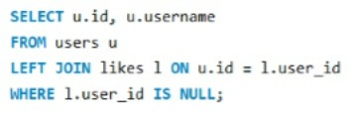
OUTPUT:
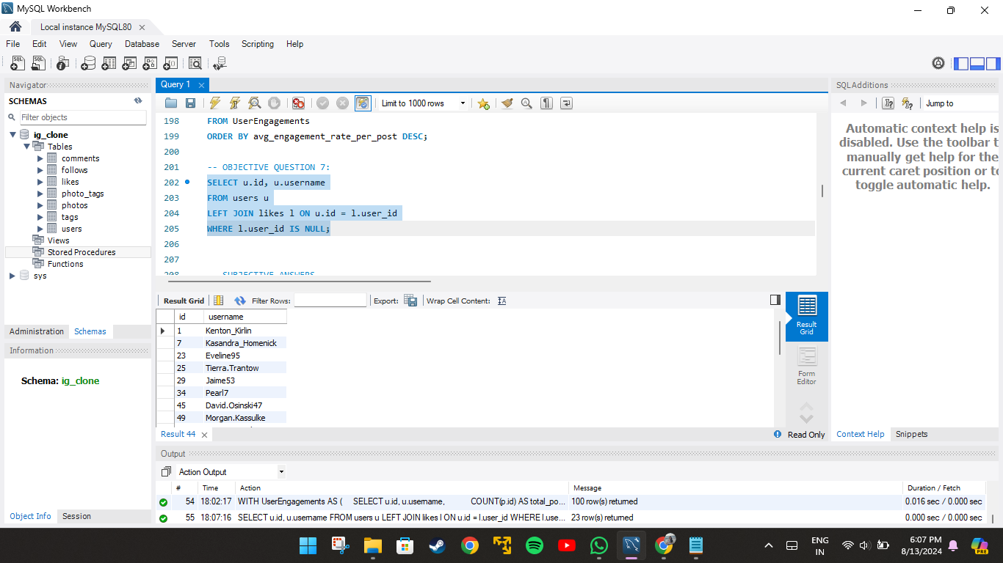

- How can you leverage user-generated content (posts, hashtags, photo tags) to create more personalized and engaging ad campaigns?
Ans: This query calculates the average number of likes for photos associated with each tag. It first computes the total likes per photo and then averages these likes across all photos tagged with each tag. The results are grouped by tag name and sorted in descending order of average likes. Finally, the top 10 tags with the highest average likes are selected and displayed.
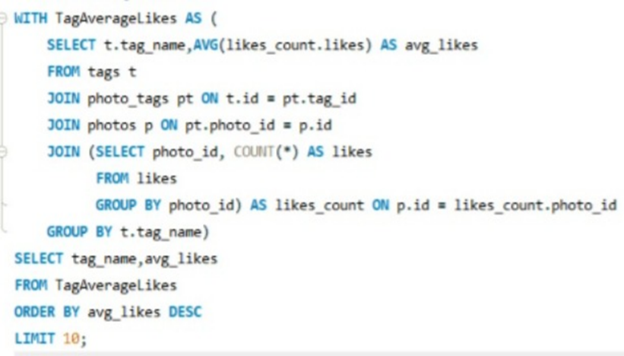
This query counts how often each tag is used in photos. It joins the tags and photo_tags tables to link tags with photos and then groups the results by tag name. The query orders the tags by their usage count in descending order, showing which tags are most frequently associated with photos. The final output displays each tag's name and the number of times it has been used.
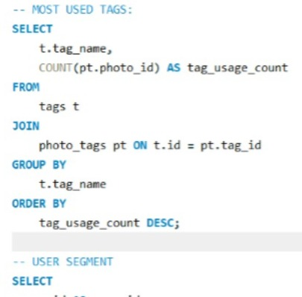

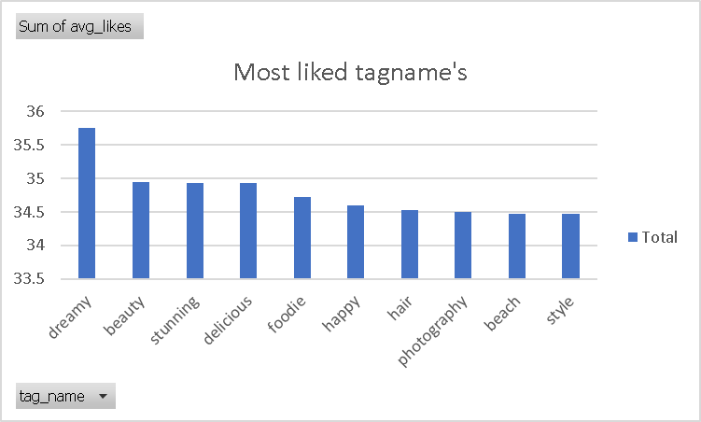
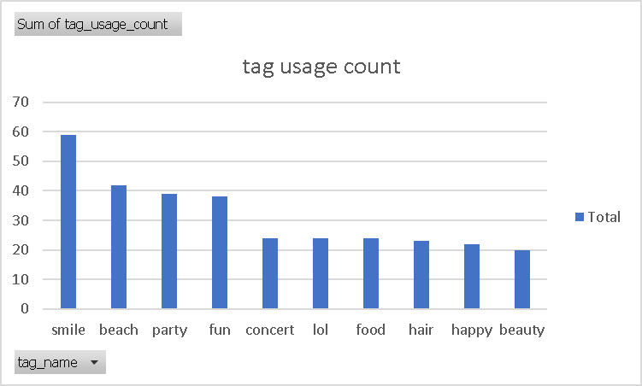
- From the above charts we can analyse that ‘dreamy’ is the most liked tag among the users and ‘smile’ is the most used tags in the photos. This way we can analyse popular tags. This can be used to make personalised ads for users.

- Are there any correlations between user activity levels and specific content types (e.g., photos, videos, reels)? How can this information guide content creation and curation strategies?
Ans: This query calculates the total number of photos, comments, and likes associated with each user and categorizes the content type they engage with. The query combines data from multiple tables—users, photos, comments, and likes—and then identifies whether a user's primary activity involves posting photos, making comments, or liking content. The final output lists each user's ID, username, the number of photos, comments, likes, and their predominant content type, helping to identify patterns in user engagement.

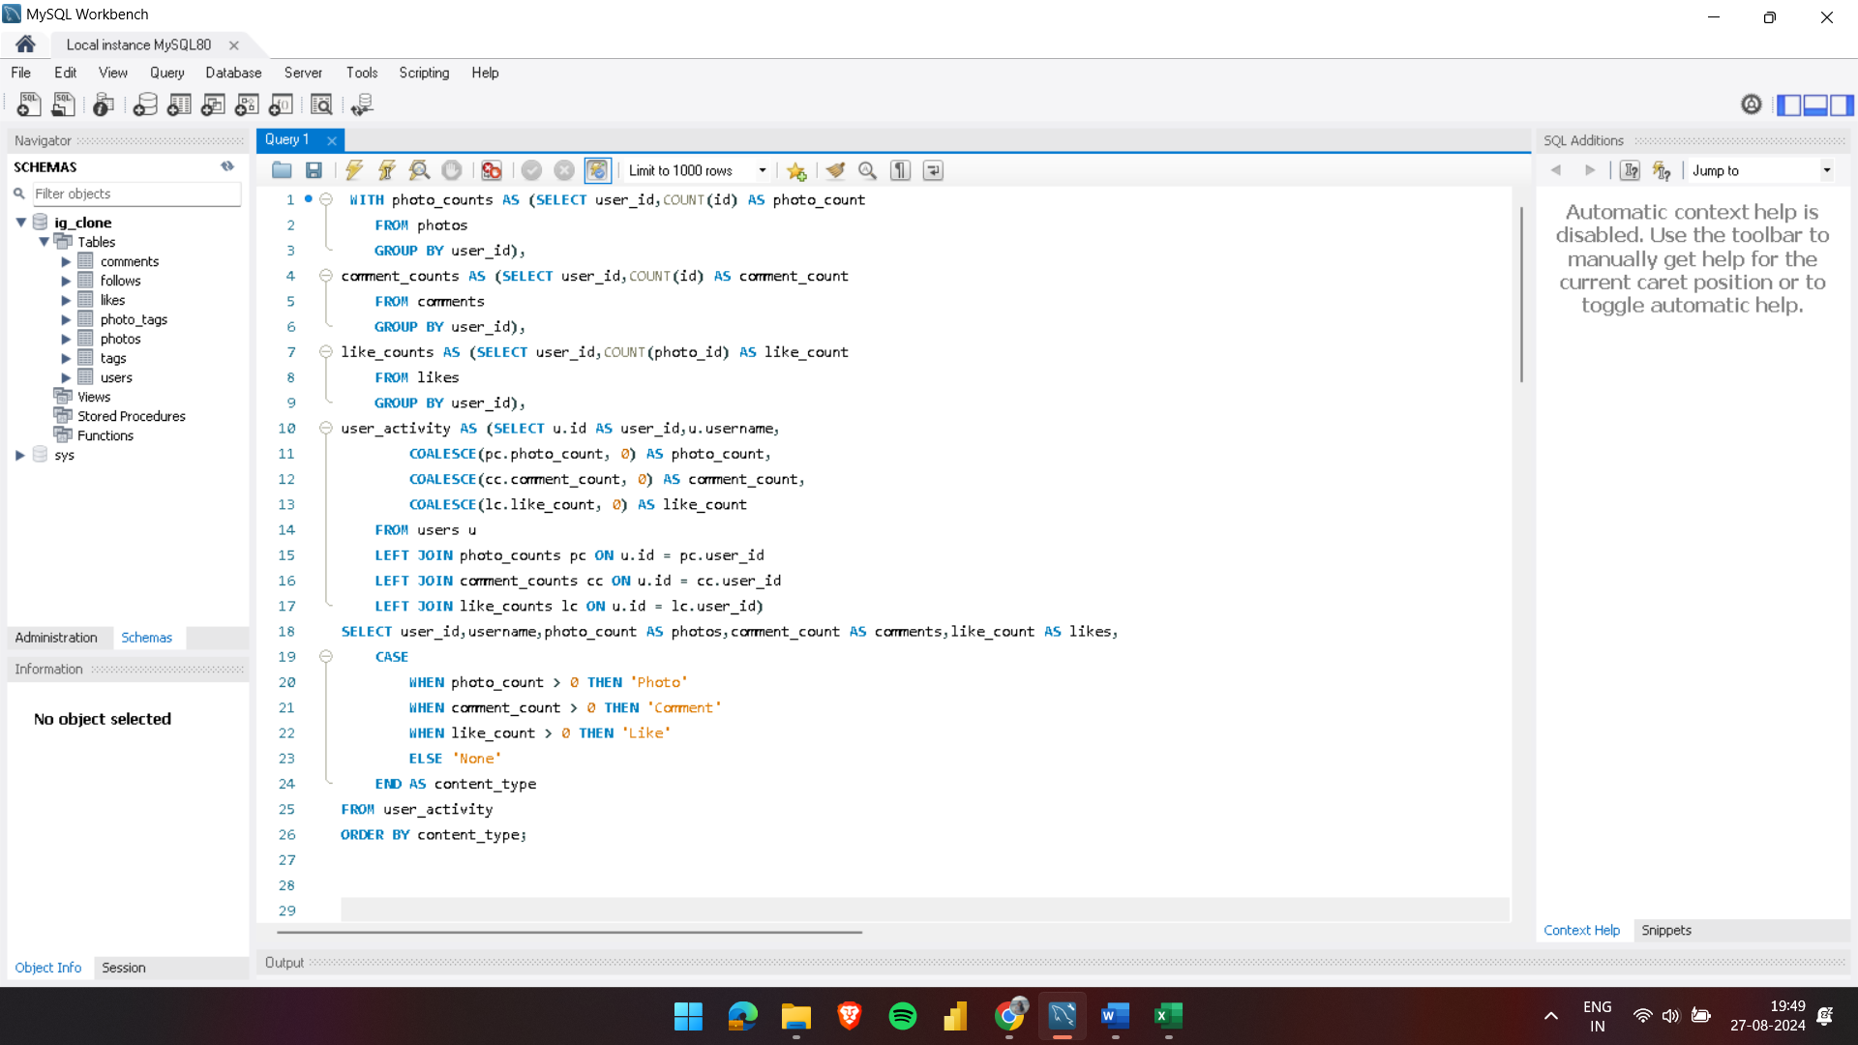

OUTPUT:
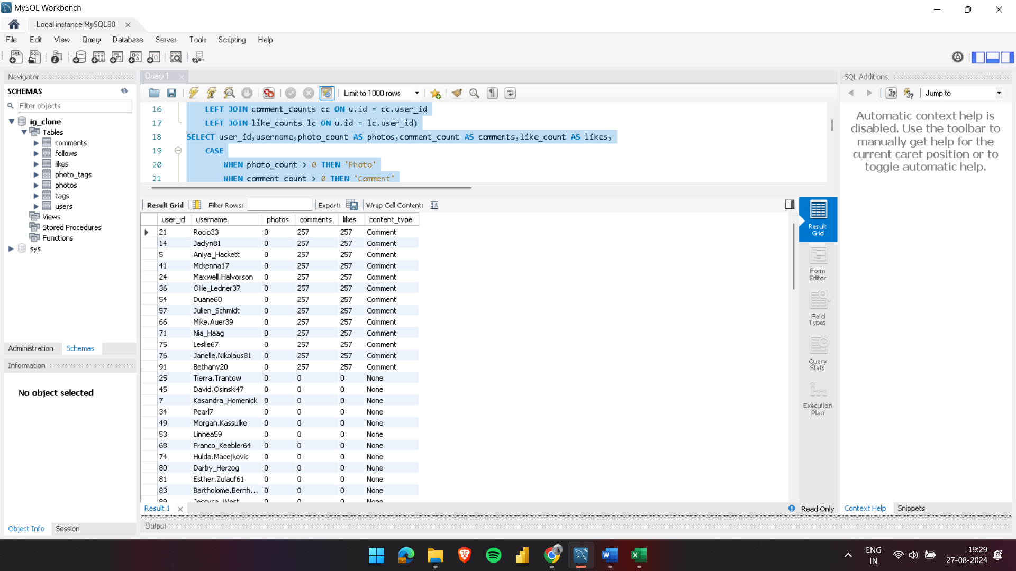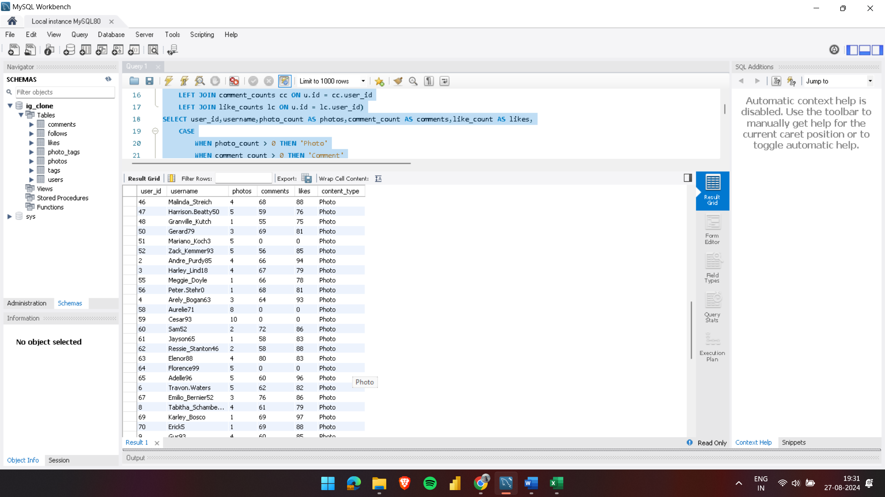

- High Comment Activity:
- Some users have a content_type labeled as "Comment" with a high comment_count, but their photo_count is zero.
- Example: The user "Rocio33" has a comment_count of 275 and a photo_count of 0. This indicates that some users are more engaged in commenting rather than posting photos.
- 13 out of 100 users are engaging in comment as content_type.
- High Photo Activity:
- Most users have a content_type labeled as "Photo" with a high photo_count with zero or more comment_count.
- Example: The user "Cesar93" has a photo_count of 10 and a comment_count of 0. This suggests that certain users prefer sharing photos rather than engaging through comments.
- 74 out of 100 users are engaged in photo as content_type .
- Not Engaged User Count:
- Some of the users have not engaged in either of the contents.
- Hence, their content_type is labelled as “None”.
- 13 out of total 100 users have this content_type i.e, 13% of the total users are inactive and haven’t engaged in either type of content.
- Engaged User Count:
- The total user count is 100, out of which 13% of them are inactive which means 87%of the users are engaging in either comment or photo as content_type.
- 13% of the users are engaged in content_type “comment”.
- 74% of users are engaged in content_type “photo”.
Correlation Insights:
- Content Preference: Users tend to specialize in either form of engagement, either commenting or posting photos. There's a clear distinction between those who prefer to contribute through photos and those who are more active in commenting. From the above analysis it can be concluded that majority of the users are engaged in content_type “photo”.

- Calculate the total number of likes, comments, and photo tags for each user.
Ans: This query calculates the total likes, comments, and photo tags for each user on the platform. It combines these counts with user information, ensuring that even users with no activity are included, with their totals set to zero.

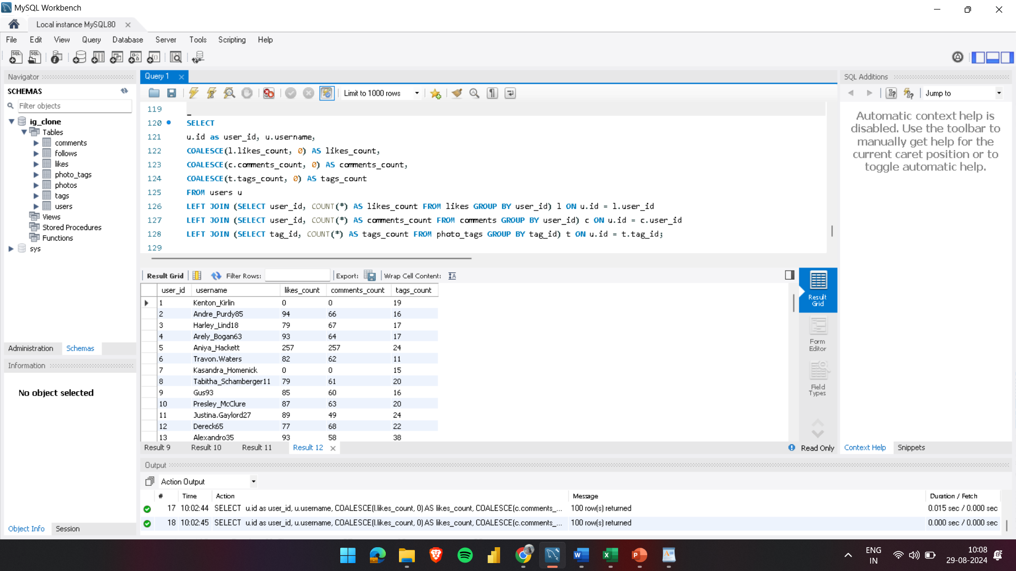

OUTPUT:

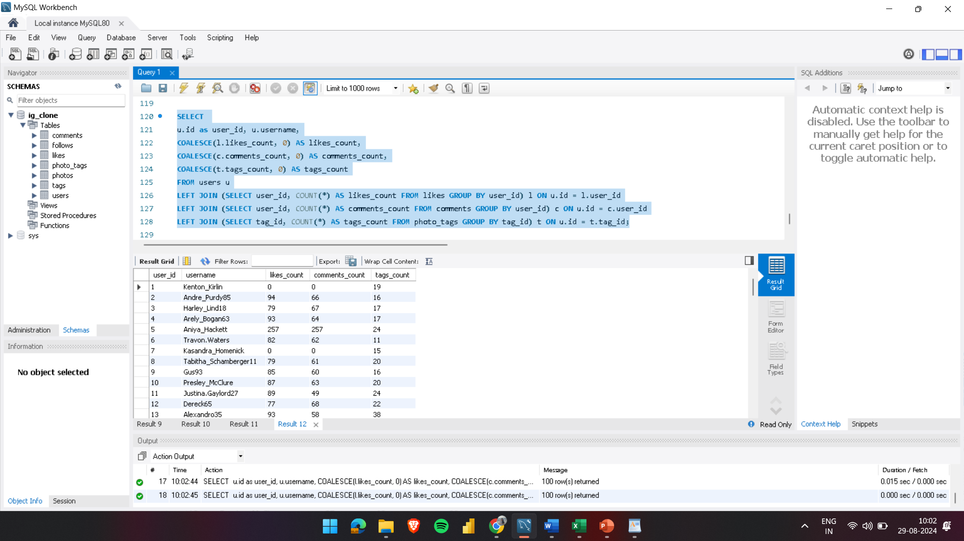
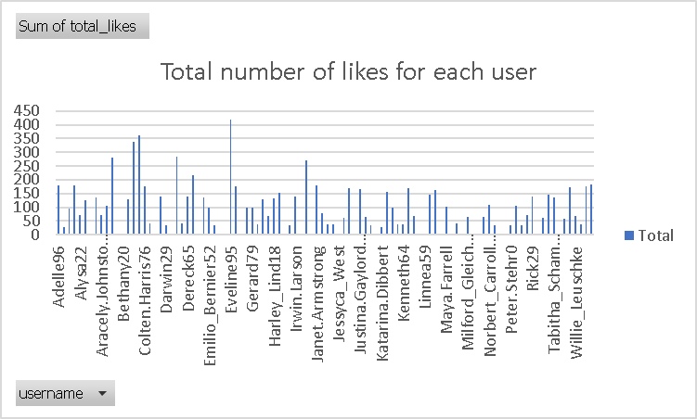
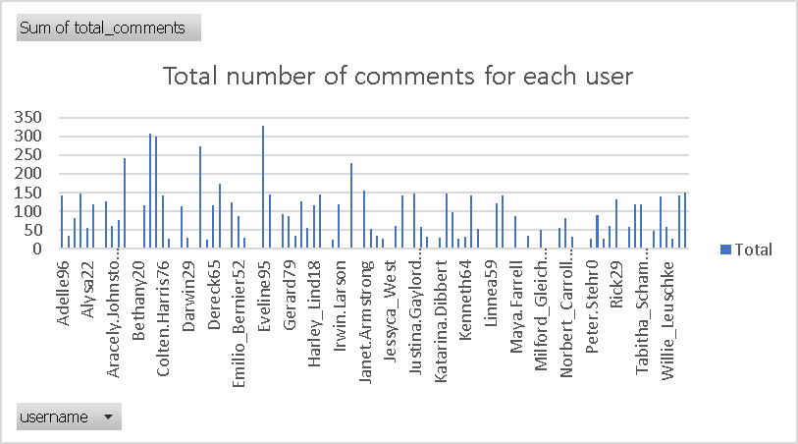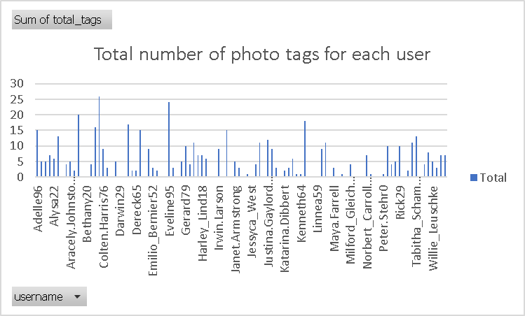

- Rank users based on their total engagement (likes, comments, shares) over a month.
Ans: This query calculates and ranks user engagement over the past month. It aggregates the total likes, comments, and tags associated with each user's photos, and sums these to compute a total engagement score. The users are then ranked based on this total engagement, with the highest engagement ranked first. The final output includes each user's ID, username, total likes, comments, tags, and their engagement rank.
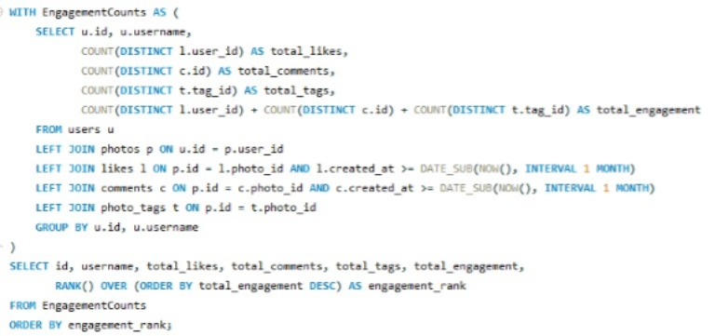
OUTPUT:
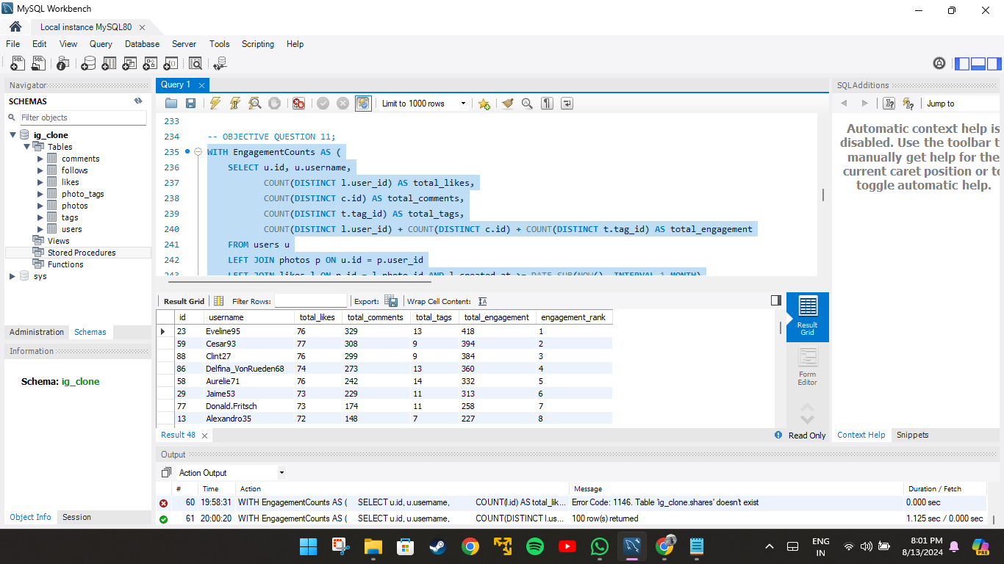

- Retrieve the hashtags that have been used in posts with the highest average number of likes. Use a CTE to calculate the average likes for each hashtag first.
Ans: This query calculates the average number of likes for photos associated with each tag. It first computes the total likes per photo and then averages these likes across all photos tagged with each tag. The results are grouped by tag name and sorted in descending order of average likes. Finally, the top 10 tags with the highest average likes are selected and displayed.
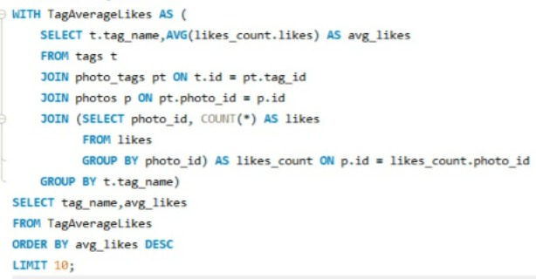
OUTPUT:
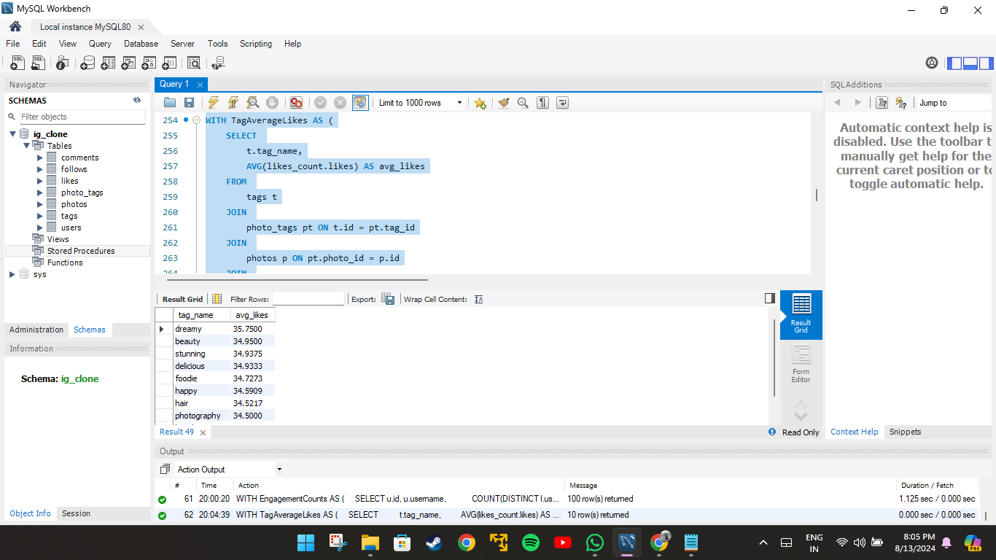


- Retrieve the users who have started following someone after being followed by that person
Ans: This query identifies pairs of users who follow each other, where one user followed the other first. It matches users based on their follow relationships and compares the timestamps to ensure that the second user followed after the first. The query returns the usernames of both users, labeled as the "follower" and "followee," for pairs where this reciprocal following occurred.

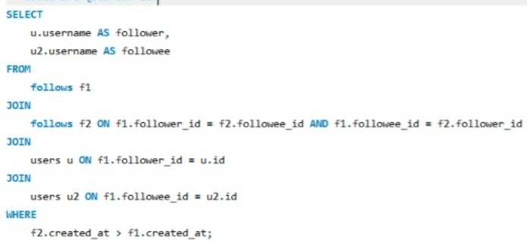
OUTPUT:
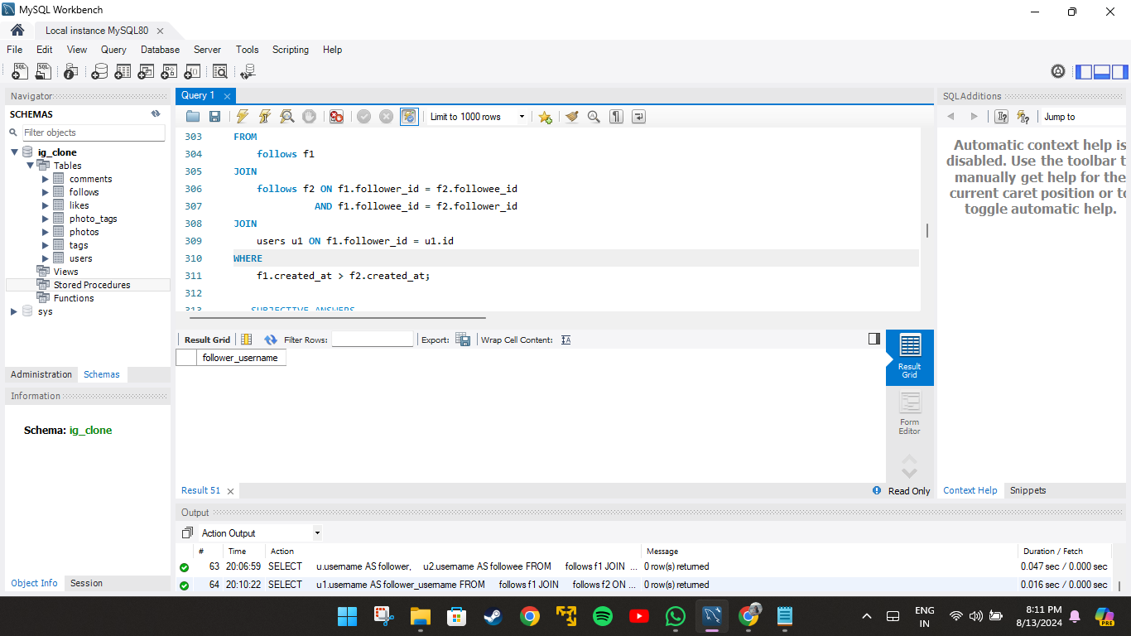

Subjective Questions

- Based on user engagement and activity levels, which users would you consider the most loyal or valuable? How would you reward or incentivize these users?
Ans: This query calculates and ranks users based on their overall engagement on a platform. It combines various activity metrics, including the number of photos posted, comments made, likes given, followers, and following count, into an engagement_score for each user. The users are then ranked by this engagement score in descending order. The final output displays the user ID, username, engagement score, and rank, but only for the user with the highest engagement score (rank 1).
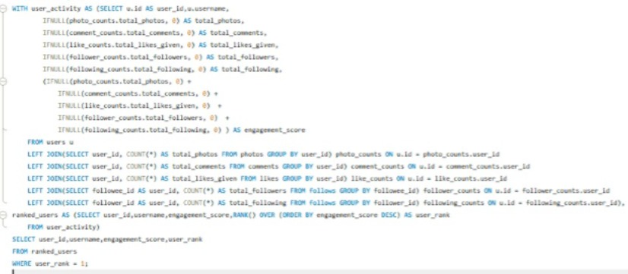
OUTPUT:
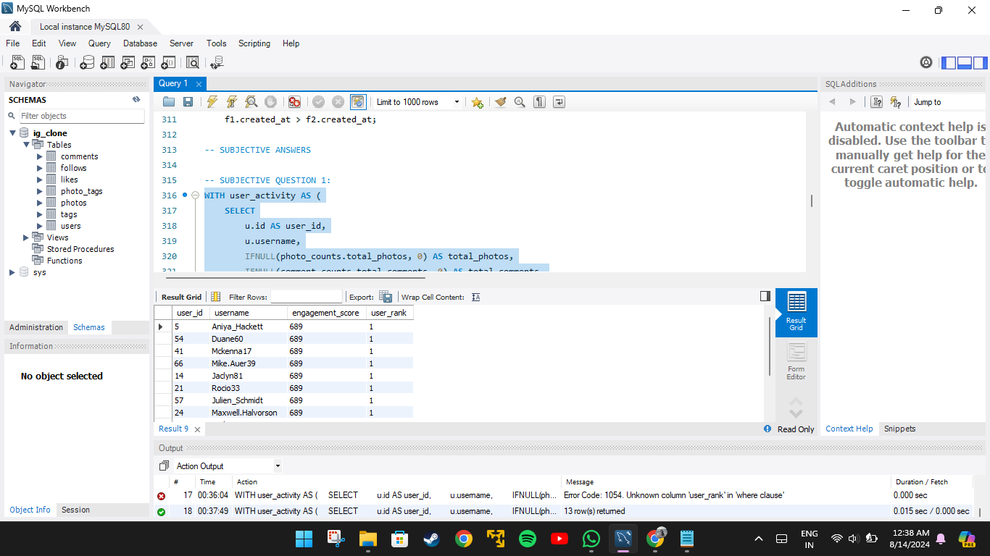
- The most loyal and valuable users would be : Aniya_Hackett,Duane60,Mckenna17,Mike.Auer39,Jaclyn81,Rocio33,Julien_Schmidt,Maxwell.Halvorson,Bethany20,Janelle.Nikolaus81,Leslie67,Ollie_Ledner37,Nia_Haag.
- This list is calculated based on the engagement score of each user which includes total photos uploaded, comments made,Likes given , total following and total followers.

- Ways to reward and incentivize the users:

- Gift cards and discounts: This is one of the common but most successful way of rewarding a valuable user.This will motivate them to use the platform more as they find these reward exciting.
- Easy access to certain tools or features: This is one of the way to help the valuable customers to promote their growth and make the process easier. Providing access to engagement insights and analytics will help them understand their users better.
- Invite to events: Inviting them to attend events hosted by the platform will help them connect with community and grow their connections and develop a deeper bond with the community.
- Custom badges or titles: This is a way of highlighting them among many other users.

- For inactive users, what strategies would you recommend to re-engage them and encourage them to start posting or engaging again?
Ans: This query calculates and ranks users based on their lowest engagement on the platform. It aggregates several activity metrics, such as the number of photos, comments, likes given, followers, and following, into an overall engagement_score. Users are then ranked in ascending order based on this score, meaning those with the lowest engagement score get the highest rank. The final output shows the user ID, username, engagement score, and rank, specifically for the user with the lowest engagement score (rank 1).
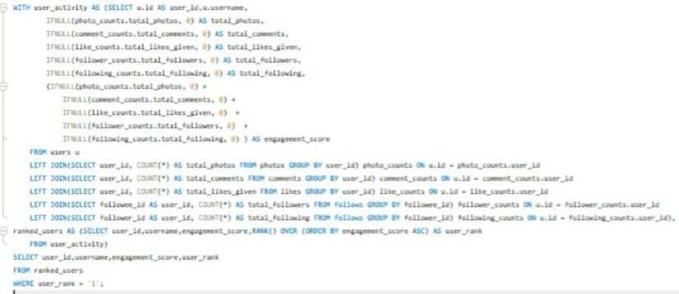

OUTPUT:
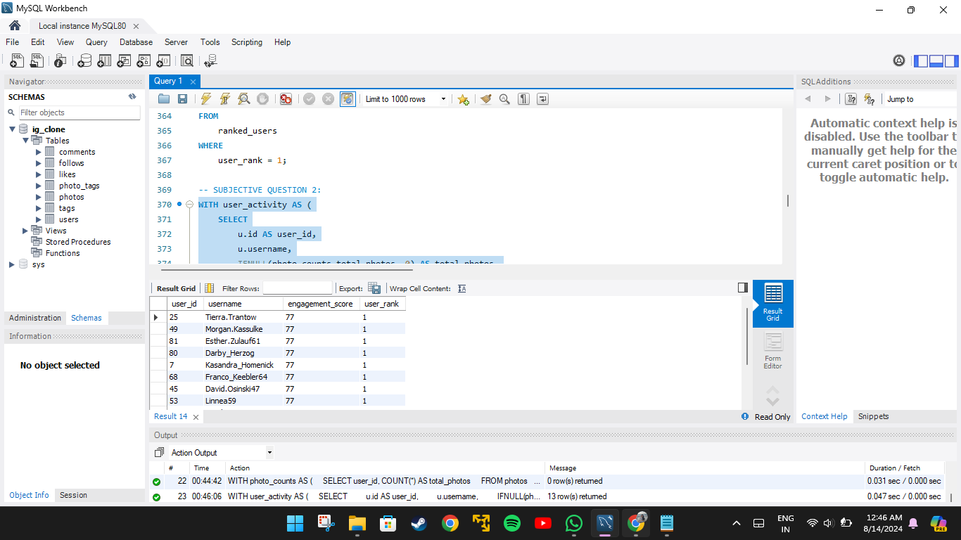
Strategies you can implement to encourage these users to start posting or engaging again:
1. Personalized Re-engagement Emails:
- Highlight Missed Opportunities: Send personalized emails showcasing trending content or posts from their connections that they’ve missed.
- Recommendations: Suggest content, groups, or hashtags they might be interested in based on their past behaviour.
2. In-App Notifications:
- Milestone Reminders: Remind them of milestones they are close to achieving, such as a certain number of followers or likes.
3. Incentivize Engagement:
- Gamification: Introduce challenges or contests with rewards for the most engaging content or for hitting specific activity milestones.
4. Simplify the User Experience:
- Content Creation Prompts: Offer prompts or templates that make it easier for users to create and share content, reducing the friction of coming up with something new.
- Onboarding Refresh: Offer a guided re-onboarding experience to remind users of platform features and benefits they might not be using.
5. Engagement-Focused Campaigns:
- Themed Weeks/Events: Organize themed content weeks or virtual events that encourage users to participate and engage.
6. Feedback Loops:
- User Surveys: Ask inactive users for feedback on why they stopped engaging. Use their input to make meaningful changes or offer solutions directly.
7. Content Discovery Enhancements:
- Explore Pages: Improve content discovery through personalized explore pages that show trending or relevant content to the user’s past interests.

- Which hashtags or content topics have the highest engagement rates? How can this information guide content strategy and ad campaigns?
Ans: This query finds the top 10 tags with the highest average engagement on the platform. It calculates the total number of posts, likes, and comments for each tag, then determines the average engagement per post. The results are ordered by average engagement in descending order.
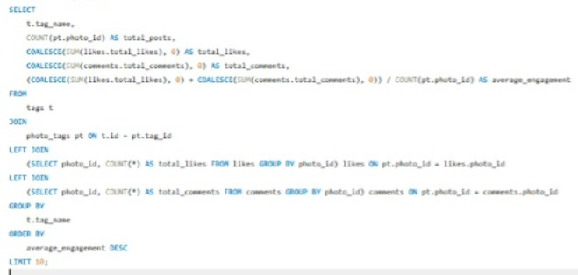
OUTPUT:
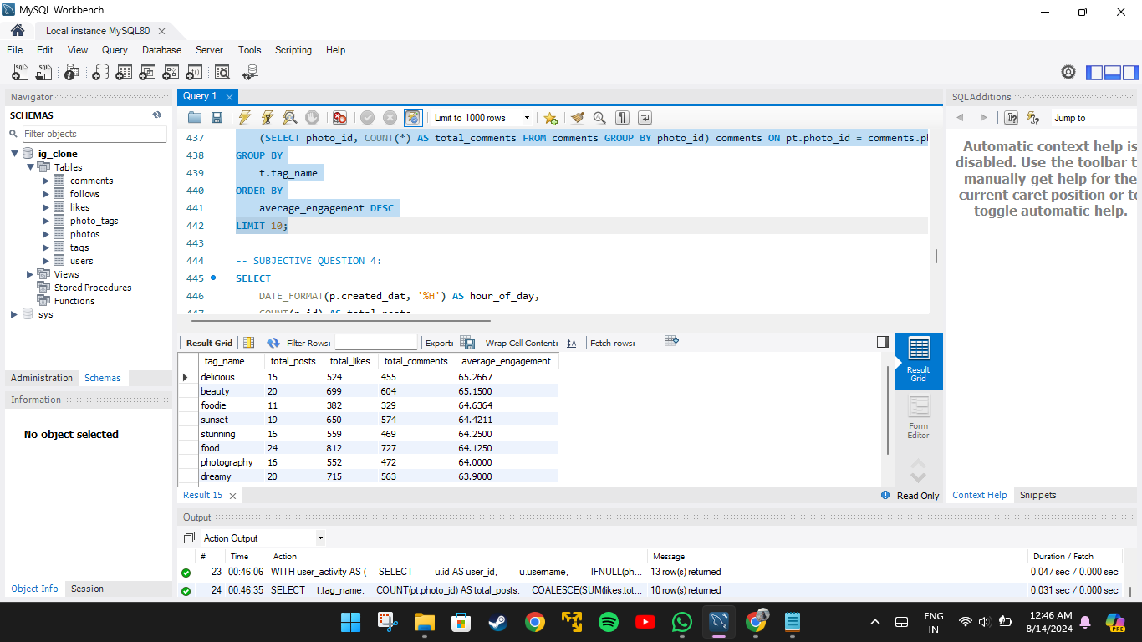
The hashtags with the highest engagement rate are: delicious,beauty,foodie,sunset,stunning,food,photography,dreamy,smile,party.
1. Content Creation and Curation
- Focus on Popular Themes: Create and curate content that aligns with these high-engagement themes. For instance, posts related to food (#delicious, #food, #foodie), beauty (#beauty, #stunning), and photography (#photography, #sunset) should be prioritized.
- User-Generated Content (UGC): Encourage users to create content around these hashtags. For example, running a campaign that invites users to share their favourite #sunset or #foodie moments can boost engagement.
2. Ad Targeting and Campaigns
- Ad Copy and Creative: Incorporate these hashtags into ad copy and creative elements. For example, an ad campaign for a new product could highlight how it fits into the #beauty or #foodie lifestyle.
- Influencer Collaborations: Partner with influencers who frequently use these hashtags and have high engagement rates. For example, a collaboration with a food influencer under #delicious or #foodie can drive targeted traffic and engagement.
- Hashtag-Based Targeting: Use these hashtags to target ads to users who have previously engaged with related content. This ensures the ads are shown to an audience already interested in these topics.
3. Engagement Optimization
- Trending Content Series: Develop a content series based on these popular hashtags. For example, a weekly #sunset or #party post could keep followers engaged and looking forward to new content.
- Cross-Promotion: Cross-promote content that features these hashtags across different social media platforms, driving more traffic and engagement back to Instagram.
- Time and Frequency: Analyze the optimal times and frequency to post content with these hashtags. For instance, posting #sunset content during evening hours may align better with user activity.
4. Content Discovery and Algorithm Boost
- Hashtag Usage for Algorithm Boost: Regularly use these high-engagement hashtags in posts to improve content discovery and algorithmic placement. Posts that use trending hashtags are more likely to be featured on the Explore page, increasing reach.
- Tailored Recommendations: Use insights from these hashtags to tailor content recommendations and suggestions for users, enhancing their overall experience and increasing engagement.

- Are there any patterns or trends in user engagement based on demographics (age, location, gender) or posting times? How can these insights inform targeted marketing campaigns?
Ans: This query analyses photo engagement by the hour of the day and day of the week. It groups photos by the hour they were created, counting the total number of posts, likes, and comments for each hour. It calculates the average engagement per post (likes plus comments divided by the number of posts) and orders the results by this average engagement in descending order.
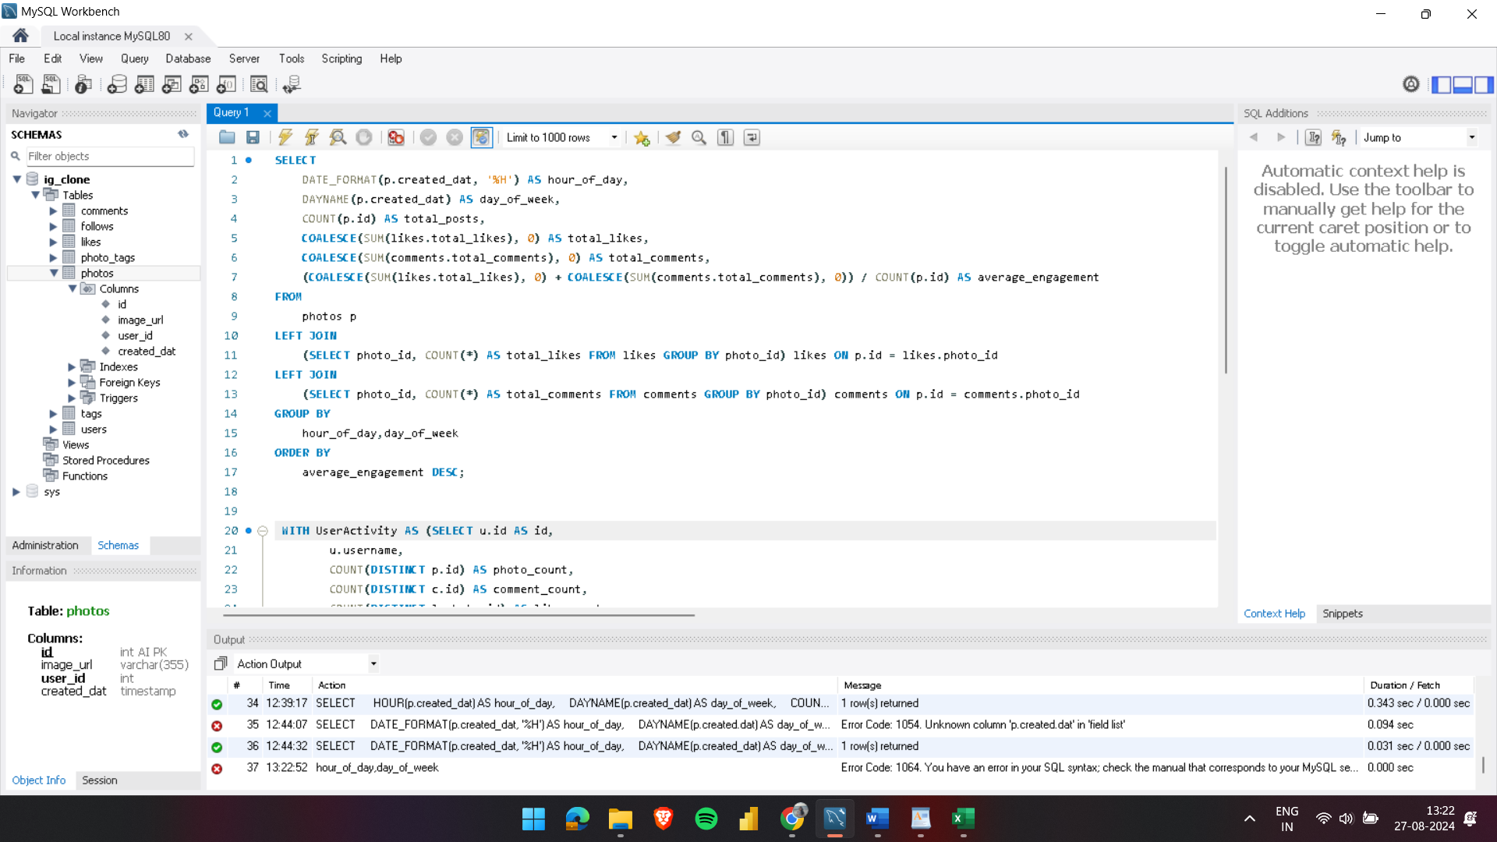
OUTPUT:
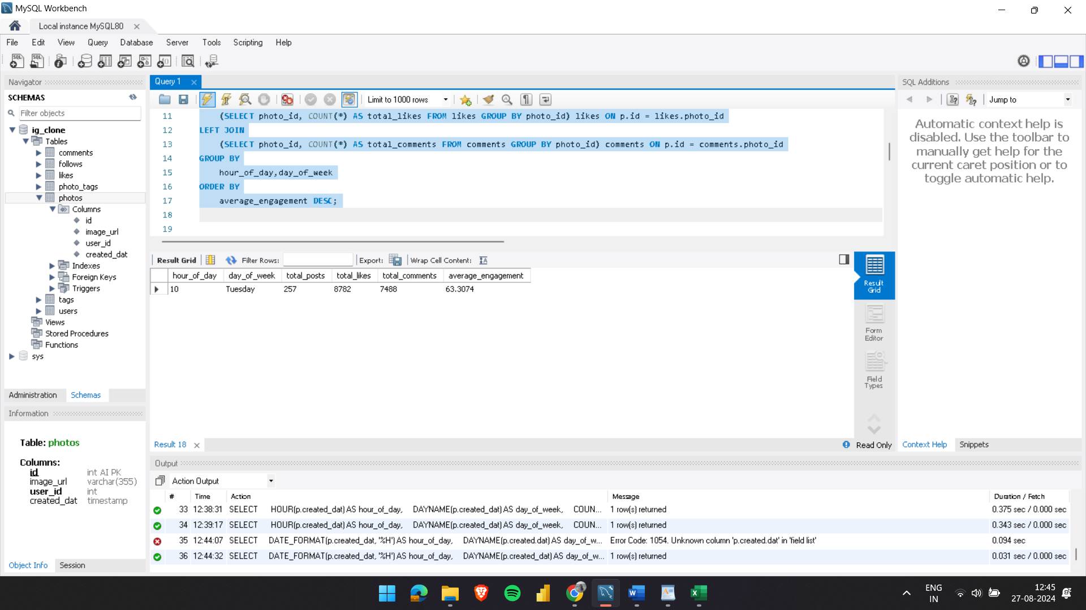
- The above output shows that most of the users are engaged at 10 AM on Tuesdays with an average engagement of 63.3 .
- With a total of 257 posts, 8782 likes and 7488 comments the average engagement rate for nearly 100 users who majorly post at 10 AM on Tuesdays is calculated.
- Therefore according to the analyses since the user engagement is high mostly during that day of week and hour this pattern can be used for targeted ad marketing.
- There are definitely patterns and trends in user engagement based on the demographics. The sunset posts, reels, videos use hashtags like #sunset, #evening, #photography etc, this content will gain more reach when posted in the evening than on the other time of the day since it will be more relatable at that time of the day.
- Similarly age and gender also matter because mostly different age groups attract different and seek different contents.
- Also location plays an important role For example, when a content is related to Japan various hashtags come under its umbrella like #anime,#sakura,#Tokyo,#lifeinJapan,#buddha,#ramen,#sushi etc. These tags are related to the location.
These insights help reach the targeted audiences easily.

- Based on follower counts and engagement rates, which users would be ideal candidates for influencer marketing campaigns? How would you approach and collaborate with these influencers?
Ans: This query ranks users based on their engagement rate. It calculates the number of followers each user has, and aggregates the total likes and comments on their photos. The engagement rate is then computed by dividing the total engagement (likes plus comments) by the number of followers, with a special case to handle users with no followers. The results are ordered by engagement rate in descending order, and ties are broken by follower count. The query retrieves the top 10 users with the highest engagement rates, including their user ID, username, follower count, total likes, total comments, total engagement, and engagement rate.
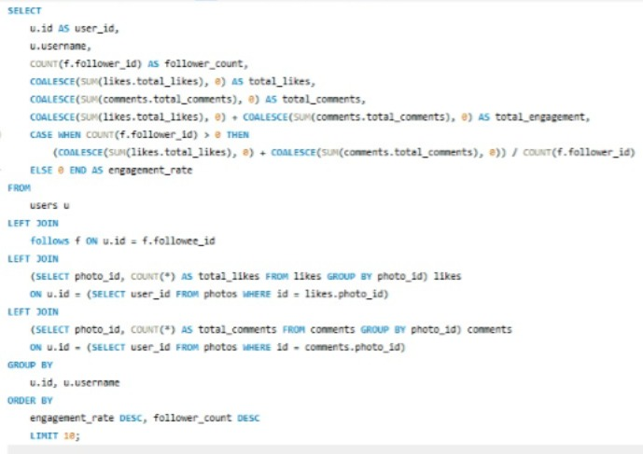
OUTPUT:
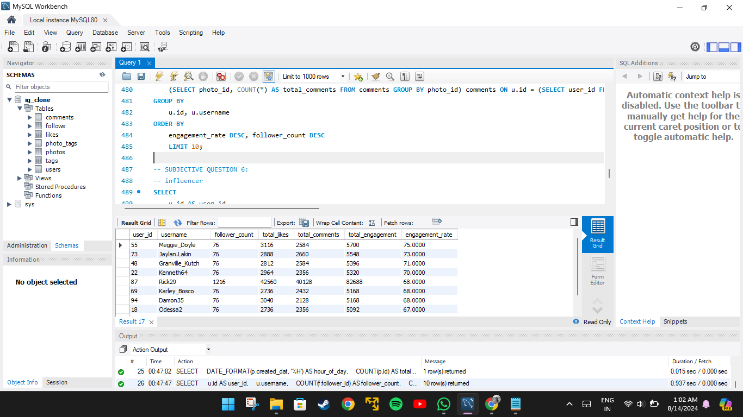

Approaching and Collaborating:
- Research & Personalization:
- Understand the influencer’s content and audience.
- Personalize outreach by mentioning specific posts or campaigns that align with your brand.
- Collaboration Strategy:
- Define clear objectives for the campaign.
- Offer creative freedom within content guidelines to maintain authenticity.
- Compensation & Incentives:
- Provide fair monetary compensation or product gifting.
- Consider long-term partnerships for sustained engagement.
- Tracking & Amplification:
- Set clear KPIs(Key Performance Indicator) to measure success.
- Amplify influencer content across your brand’s channels for maximum reach.

- Based on user behaviour and engagement data, how would you segment the user base for targeted marketing campaigns or personalized recommendations?
Ans: This SQL query calculates and classifies user engagement on a platform. It starts by selecting user details such as user_id and username from the users table. The query then aggregates data on user interactions by joining the likes and comments tables to compute the total number of likes and comments per user. Additionally, it counts the number of photos each user has posted from the photos table.
- The engagement rate is calculated as the total likes and comments divided by the number of photos.
- Based on the engagement rate, users are categorized into 'High', 'Medium', or 'Low' engagement levels.
The data is joined and grouped by user, and the final results are ordered by engagement rate in descending order. This query provides insights into user activity and helps in identifying different engagement levels among users.

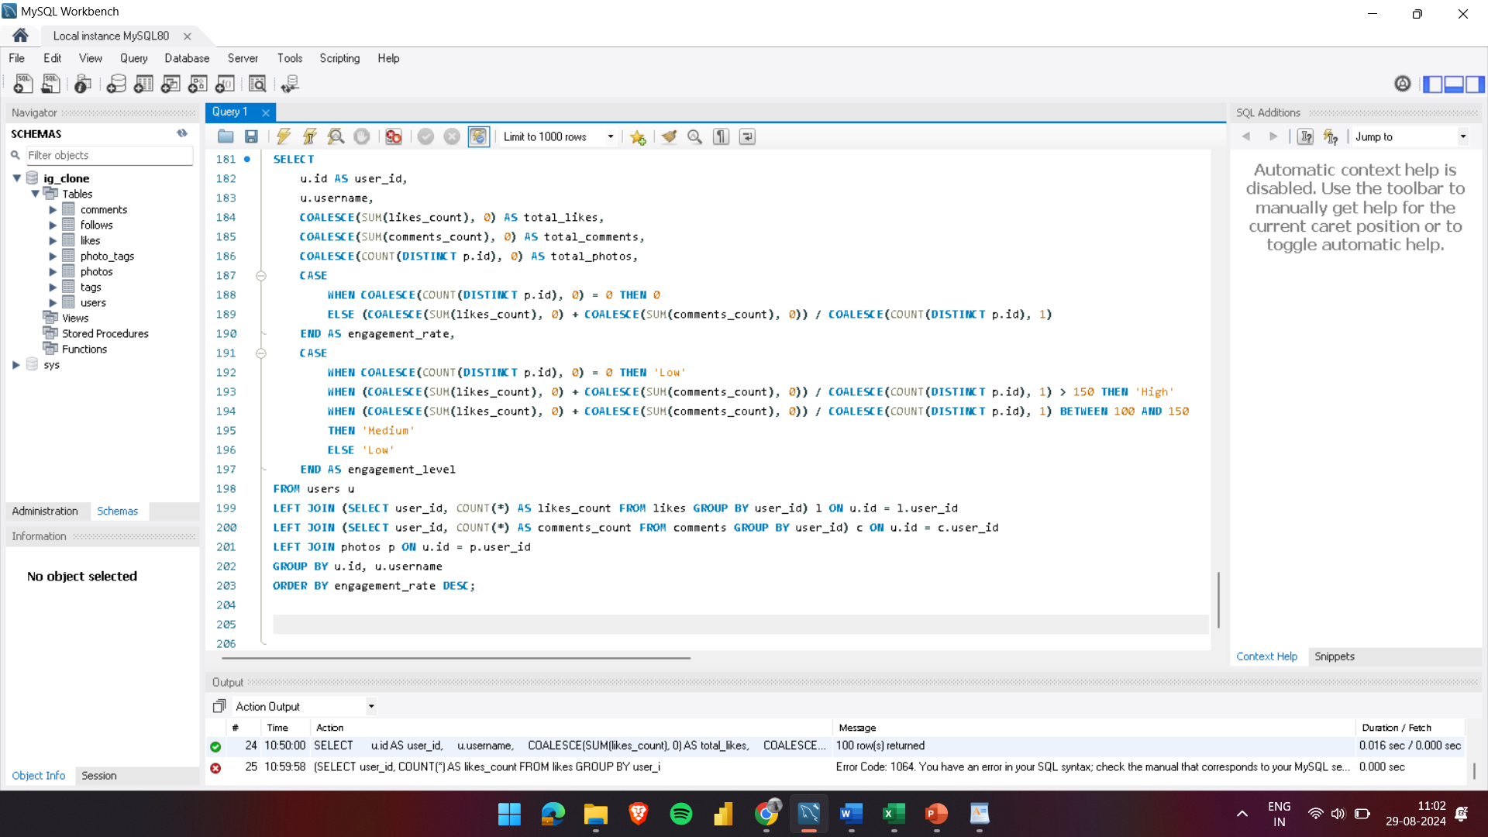

OUTPUT:
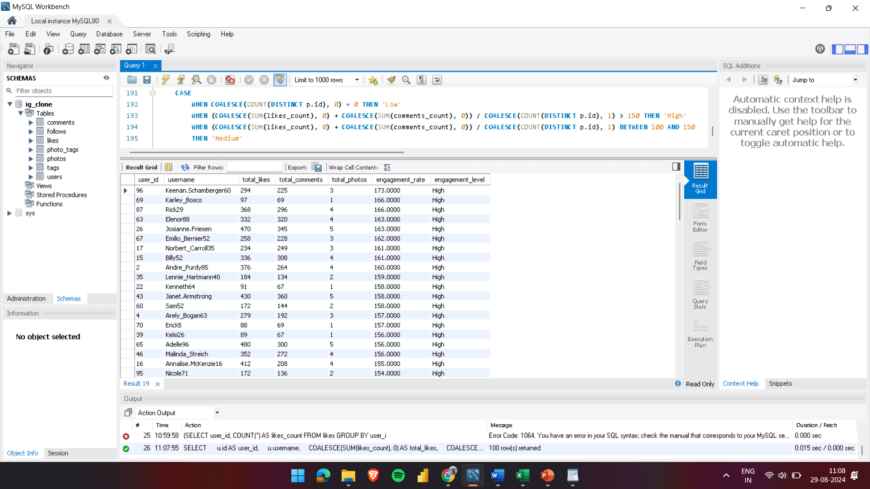
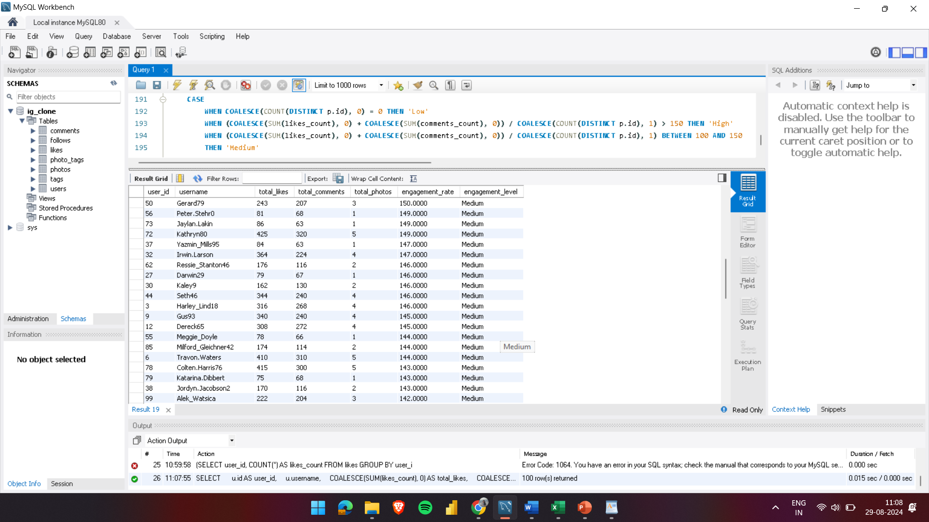
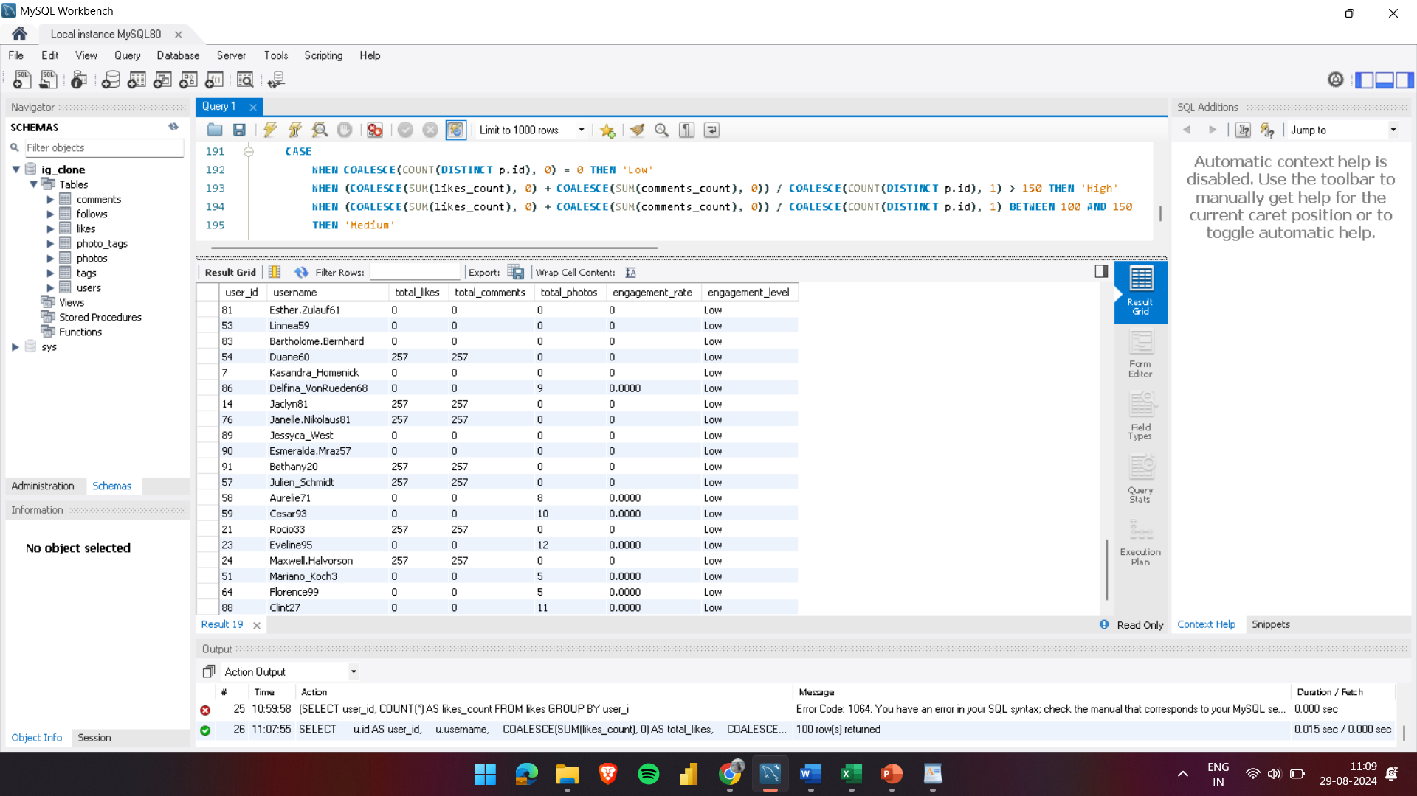

- 30% of the users are high engagement users i.e, 30 out of total 100 users are highly engaged.
- 34% of the users are medium engagement users i.e, 36 out of total 100 users are medium- engaged.
- 36% of the users are low engagement users i.e, 36 out of total 100 users are low- engaged.

- For targeted marketing campaigns or personalized recommendations based on user segmentation, the strategies are:

- High Engagement Users:
- Marketing Campaigns: Create exclusive offers or early access to new products. Highlight premium features or products that cater to their interests and activity patterns.
- Personalized Recommendations: Suggest content, products, or services similar to what they frequently engage with. Tailor notifications and updates to their preferences and interaction history.
- Medium Engagement Users:
- Marketing Campaigns: Use targeted ads to encourage more engagement, such as special promotions or interactive content. Engage them with incentives to increase their interaction level, like limited-time discounts.
- Personalized Recommendations: Recommend content or products that align with their past behaviour but also include some new or trending options to spark increased engagement.
- Low Engagement Users:
- Marketing Campaigns: Focus on re-engagement strategies. Offer discounts, reminders, or educational content to rekindle their interest. Consider using win-back campaigns with personalized messages.
- Personalized Recommendations: Introduce them to popular or highly engaging content or products. Use prompts or curated content to attract their attention and encourage them to interact more.

Implementation Steps:
- Data Analysis: Continuously analyze user behavior and engagement metrics to refine segmentation and understand changing patterns.
- Custom Messaging: Develop targeted messaging and offers tailored to each segment’s characteristics and interests.
- A/B Testing: Test different approaches within each segment to find the most effective strategies.
- Monitor and Adjust: Track the performance of campaigns and recommendations. Use feedback and results to make necessary adjustments and improve effectiveness.

By leveraging user behaviour and engagement data, you can create more effective marketing campaigns and provide personalized recommendations that resonate with each user segment.

- If data on ad campaigns (impressions, clicks, conversions) is available, how would you measure their effectiveness and optimize future campaigns?
Ans: 1. Measuring Campaign Effectiveness:
- Key Performance Indicators (KPIs):
- Impressions: Track the number of times an ad is shown to users. High impressions with low engagement might indicate the need for better targeting.
- Click-Through Rate (CTR): Calculate CTR by dividing clicks by impressions. A low CTR suggests that the ad creative or copy may need adjustment.
- Conversion Rate: Track the percentage of clicks that lead to a desired action (e.g., purchase, signup). This indicates the effectiveness of the ad in driving meaningful actions.
- Return on Ad Spend (ROAS):
- Calculate ROAS by dividing the revenue generated from the campaign by the amount spent on ads. A higher ROAS indicates a more profitable campaign.
- Customer Acquisition Cost (CAC): Measure how much it costs to acquire a new customer through the campaign. Compare CAC against the Customer Lifetime Value (CLV) to assess long-term profitability.
- Impression Share:
- Monitor the percentage of impressions your ad receives compared to the total available impressions. A higher impression share means your ad is being shown more frequently in relevant contexts.
- Use this to assess ad visibility and compare performance against competitors.
- Bounce Rate:
- Track the percentage of users who click on your ad but leave the landing page without engaging. A high bounce rate may indicate a disconnect between ad content and landing page relevance.
- Optimize landing pages to better match user expectations set by the ad.

2. Optimizing Future Campaigns:
- Ad Creative Optimization:
- Regularly refresh ad creatives (images, videos, copy) to prevent ad fatigue and maintain user interest.
- Use insights from top-performing creatives to inform design and messaging for future campaigns.
- Budget Allocation:
- Analyze which campaigns or channels deliver the best ROAS and reallocate budget accordingly. Focus more on high-performing ads or audience segments.
- Adjust bidding strategies (e.g., manual vs. automated) to maximize efficiency based on campaign goals.
- Frequency Capping:
- Implement frequency capping to limit the number of times an individual sees your ad. This prevents ad fatigue and improves the user experience.
- Test different frequency caps to find the optimal balance between exposure and engagement.
- Landing Page Optimization:
- Continuously improve landing pages based on user behavior data (e.g., heatmaps, session recordings). Ensure fast load times, clear CTAs, and mobile optimization.
- Align landing page content with the ad's message to increase relevance and conversion rates.
- Cross-Channel Attribution:
- Use attribution models (e.g., first-click, last-click, linear) to understand the impact of different channels (e.g., social media, search, display) on conversions.
- Optimize campaign strategies by investing in channels that contribute most effectively to the customer journey.

- How can you use user activity data to identify potential brand ambassadors or advocates who could help promote Instagram's initiatives or events?
Ans: To identify potential brand ambassadors or advocates:
- High Engagement Users: Identify users who consistently engage with content (e.g., likes, comments, shares) and have a strong presence in specific niches or communities. These users are likely to be influential within their circles.
- Content Creators: Look for users who frequently create high-quality, original content that aligns with Instagram’s brand values and initiatives. These users can naturally advocate for the platform through their content.
- Positive Sentiment: Use sentiment analysis to identify users who regularly express positive opinions about Instagram and its features. These users are likely to be genuine advocates who can promote the brand authentically.
- Frequent Interactions: Track users who regularly interact with Instagram's official account or engage in discussions about Instagram on other platforms. Their enthusiasm and active participation make them ideal candidates for brand advocacy.
- Personalized Outreach: Contact them with a message that highlights their influence and how they align with Instagram's initiatives.
- Value Proposition: Offer incentives such as exclusive access, features, or rewards for participating in campaigns.
- Collaboration: Set Clear Expectations: Define the campaign goals, the content you expect them to create, and how they can share their involvement.
- Offer Creative Freedom: Allow them to create content in their style to maintain authenticity.
- Long-term Partnership: Consider establishing ongoing relationships with top-performing ambassadors to promote future initiatives or events.

- How would you approach this problem, if the objective and subjective questions weren't given?
Ans: Approach:

- Firstly understand and analyse the data.
- The data is important in analysing the requirements of the question asked. In this case the data is insufficient and has data of 100 users only.

- Identifying key metrics:
- Engagement metrics: the engagement rate of each user by calculating the likes, comments and tags by each user and photos. Also analysing the followers and following count of each user to identify rising influencers and creators.
- Retention metrics: Identifying active users who constantly interact with users constantly and keep them engaged with their posts over various periods of time(weekly,monthly,yearly). Also identifying inactive users will help create campaigns and events to keep them more active by understanding their needs and requirements.
- Acquisition metrics: By analysing the growth of new users and identifying how the high engagement users influence the growth of new users.
- User segmentation and targeted marketing:
- Segment by Engagement Level: Group users based on their activity (e.g., highly active, moderately active, and inactive users). Identify users with a high follower count and engagement rate for potential brand ambassador roles.
- Personalized Content: Use segmentation to deliver personalized content recommendations to different user groups.Target inactive or low-engagement users with re-engagement campaigns, such as email reminders or in-app notifications.
- Analysing trends and their influence on high user engagement:
- Identifying the trends by analysing the hashtags used by the users and also analysing various metrics of it i.e, most liked hashtags, most used hashtags. This will help us understand what are the topics that the users are interested in and consume more time on the platform.
- Using this data we can find influencers for each type of hashtags that are analysed and create a campaign for the targeted users.
- Develop models to predict user churn, potential influencers, or content that is likely to go viral.
- For example , since #smile is one of the most used tagname, the marketing team can create campaigns like #beauty_is_in_smile and ask the users to post a photo of them smiling and use various other hashtags along with it like #positivevibes, #happiness etc associated with it along with the campaigning hashtag. This will also drive the user engagement rate and increase its growth spontaneously.
- Feedback:
- Use various techniques like as discussed earlier i.e, clicks,and user browsing data to understand the audiences more deeply. This will help understand what the users are looking for.
- Take feedback on the campaigns done to understand its effectiveness and work on the ups and downs of it so that the next campaign can be developed better than this.
- Working on the feedback is one the the most important part of the process.

- Assuming there's a "User_Interactions" table tracking user engagements, how can you update the "Engagement_Type" column to change all instances of "Like" to "Heart" to align with Instagram's terminology?
Ans: THE QUERY:
UPDATE User_Interactions
SET Engagement_Type = 'Heart'
WHERE Engagement_Type = 'Like';

Steps to make the update:
- Verify Consistency: Check that "Like" is the only term used in the database to ensure a comprehensive update.
- Apply Update: Implement the change to replace "Like" with "Heart" in the Engagement_Type column, ensuring uniform application across all records.
- Test the Change: Run tests in a controlled environment to confirm that the update does not disrupt platform functionality or user experience.
- Inform Users: Notify users about the terminology change, explaining the update and its purpose through in-app messages or announcements.
- Monitor Results: Observe user interactions and system performance after the update to ensure the change has been implemented correctly and that users are adjusting well.

